LAB 321Assignment | Type: | LongAssignment
LAB 321Assignment | Code: | J3.L.P0061
LAB 321Assignment | LOC: | 400
LAB 321Assignment | Slot(s): | 10

Title: Search Restaurant Information

Background
Restaurant provide services that customer can order a party online

Program Specifications

Program a web site display list of restaurant

Features:

This website contains following main functions
- Function 1: Search Restaurant
  - The restaurant will be searched by restaurant name, address
  - The restaurant list must be paging
- Function 2 Display Restaurant Details
  - List of rating information
  - Rating
  - Detailed information of restaurant

Database description
- Database must contain order detail information displayed on the screen

Expectation of User interface:

PIC 1: Search Restaurant

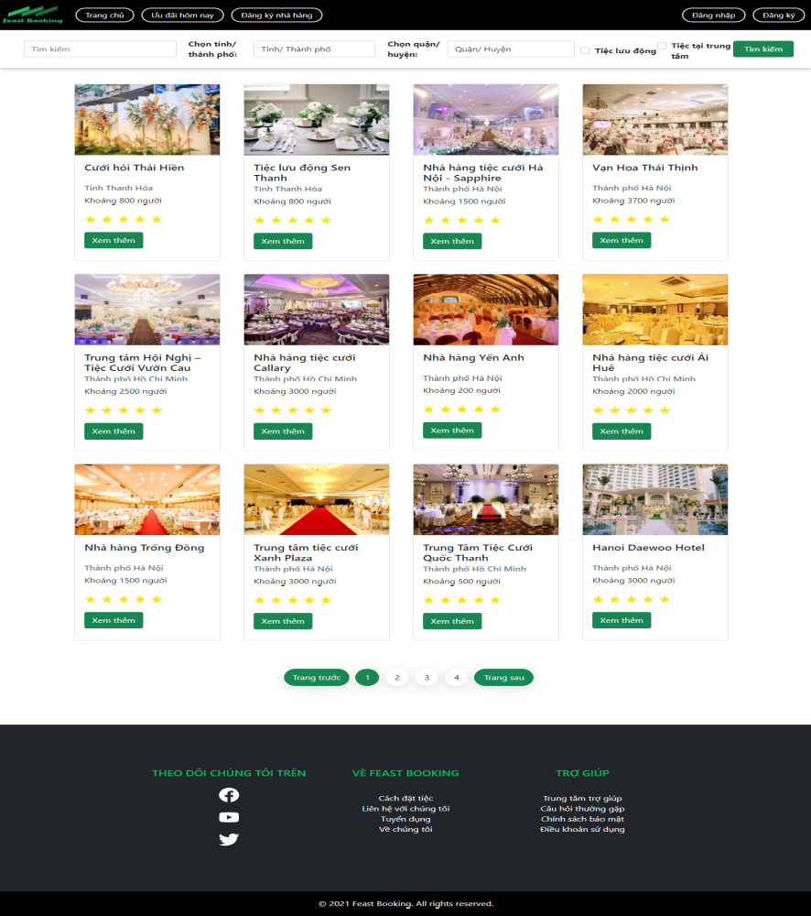

Note: The following fields must be displayed
- Restaurant Description
- Restaurant volume
- Address of restaurant
- Rating
- Previous/Next button
- Search button and City, District, Name of Restaurant
- Detail button : When user click on “Details” button, the system will display the Restaurant Detail page as PIC02
- Input Search field. When user click on “Search” button, the system will search all restaurant which match restaurant name and address

PIC 2: Restaurant Details

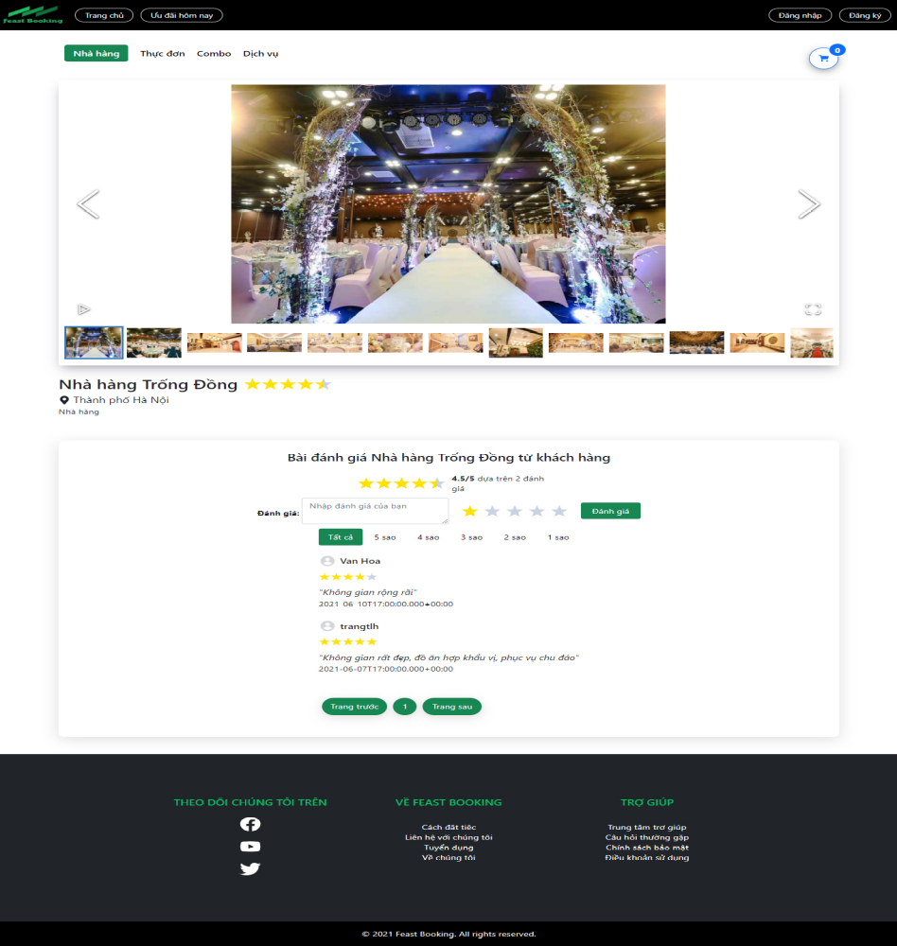

Note: The following fields must be displayed
- All fields in the screen must be got from database
- When user click on “Rating”, the rating information will be updated into database
- When user click on “Home page”, the Restaurant list will be displayed

Guidelines
- Step 1 : Create web layout
- Step 2 : Create prototype
- Step 3 : Design database base on created prototype
- Step 4 : Code & Test

